ARIN

🌐 What Is ARIN?
# Source: Chatgpt (GPT‑5 Mini) at [12/15/2025]
ARIN stands for American Registry for Internet Numbers. It is one of the five Regional Internet Registries (RIRs) responsible for managing and distributing:
- IP address blocks (IPv4 and IPv6)
- Autonomous System Numbers (ASNs)
…for organizations located in the United States, Canada, and parts of the Caribbean and North Atlantic.

🧠 Simple Definition:
# Source: Chatgpt (GPT‑5 Mini) at [12/15/2025]
ARIN is the organization that gives out IP addresses and ASNs to ISPs, companies, and other entities in North America and nearby regions.

🌍 ARIN's Coverage Region
# Source: Chatgpt (GPT‑5 Mini) at [12/15/2025]
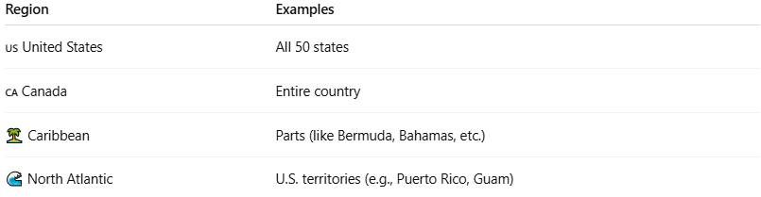

Region | Examples
🇺🇸 United States | All 50 states
🇨🇦 Canada | Entire country
🏝️ Caribbean | Parts (like Bermuda, Bahamas, etc.)
🌊 North Atlantic | U.S. territories (e.g., Puerto Rico, Guam)

🧩 ARIN’s Core Functions
# Source: Chatgpt (GPT‑5 Mini) at [12/15/2025]
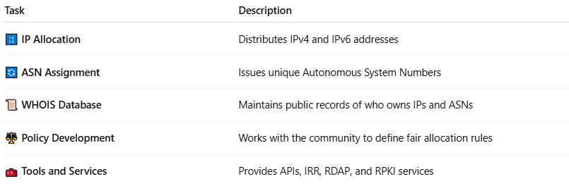

Task | Description
🔢 IP Allocation | Distributes IPv4 and IPv6 addresses
🔄 ASN Assignment | Issues unique Autonomous System Numbers
📜 WHOIS Database | Maintains public records of who owns IPs and ASNs
⚖️ Policy Development | Works with the community to define fair allocation rules
🧰 Tools and Services | Provides APIs, IRR, RDAP, and RPKI services

🧾 Example WHOIS Lookup via ARIN
# Source: Chatgpt (GPT‑5 Mini) at [12/15/2025]
For IP address 8.8.8.8 (Google DNS), ARIN WHOIS would show:
- Owner: Google LLC
- ASN: AS15169
- Registered with: ARIN
You can search this at https://whois.arin.net

📚 ARIN vs Other RIRs
# Source: Chatgpt (GPT‑5 Mini) at [12/15/2025]
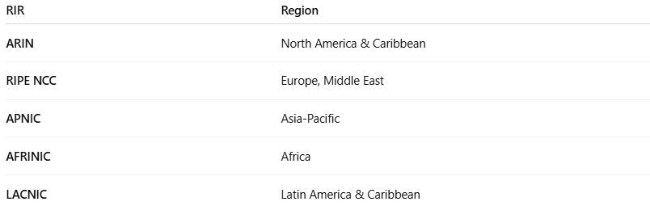

RIR | Region
ARIN | North America & Caribbean
RIPE NCC | Europe, Middle East
APNIC | Asia-Pacific
AFRINIC | Africa
LACNIC | Latin America & Caribbean

✅ Summary
# Source: Chatgpt (GPT‑5 Mini) at [12/15/2025]
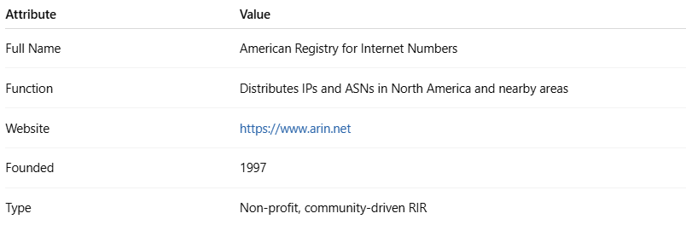

Attribute | Value
Full Name | American Registry for Internet Numbers
Function | Distributes IPs and ASNs in North America and nearby areas
Website | https://www.arin.net
Founded | 1997
Type | Non-profit, community-driven RIR

